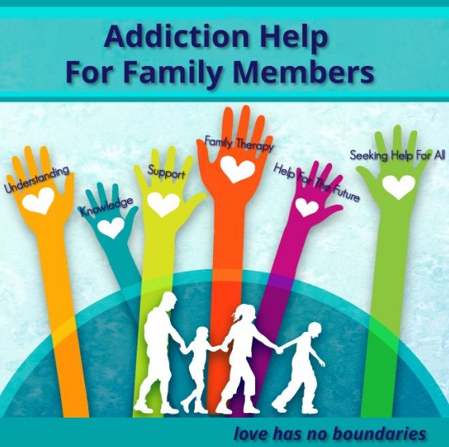
Family Educational Program for Family Members living with addiction issues

Does someone you love have alcohol or/and drug issues?

We know how difficult this is. Addiction is a complex issue that affects individuals and their families and the wider community. Families can become disconnected, our relationships suffer and we can feel isolated and helpless.

F.A.S.N are hosting the highly recommended Family Educational Program for Family Members developed by the The Rise Foundation, which offers practical support, relevant education, coping strategies and the opportunity for people to connect through their shared experiences.

One program will run in the following area: Claremont Stadium, Commons Road, Duffland, Navan, Co. Meath.

Starting Date: 15 October 2020 @ 6.30pm

Please contact F.A.S.N for further details or to book your place on the following numbers:

087 904 6405 / 042 935 5251 Email: info.fasn@gmail.com

This initiative is funded by Pobal through the Healthy Ireland Fund with the support of Meath Local Sports Partnership and Meath CYPSC.



